|  |
| --- |
| MainWindow |
| +move_left();  +move_up_new();  +move_right_new();  +move_down_new();  +move_left_new();  +ramdom();  +start();  +lose();  +the_score();  +restart();  +assign();  +trace_back(); |
| -fuck:QPixmap pointer;  -zero[11]:QPixmap;  -box[4][4]:int;  -before_box[4][4]:int;  -output_box[4][4]:QPixmap pointer;  -score:int;  -win_time:int; |

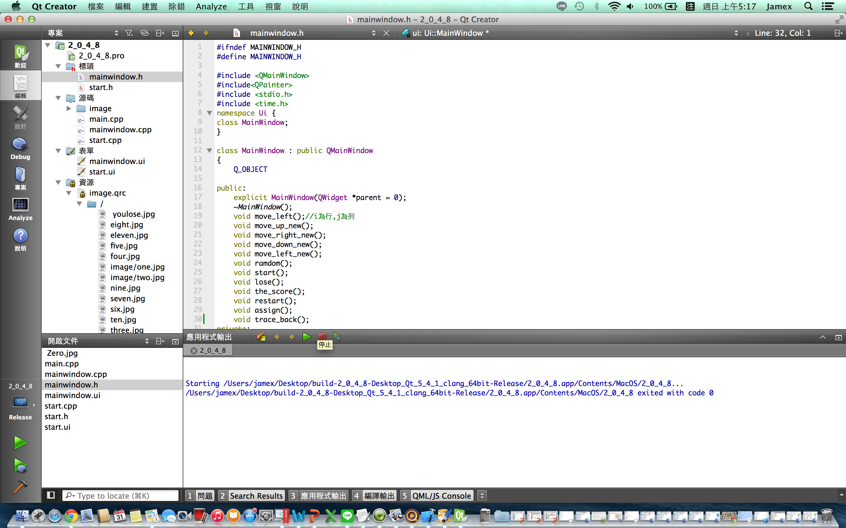

|  |
| --- |
| Start |
| -on_pushButton_clicked(); |
| -m:MainWindow; |

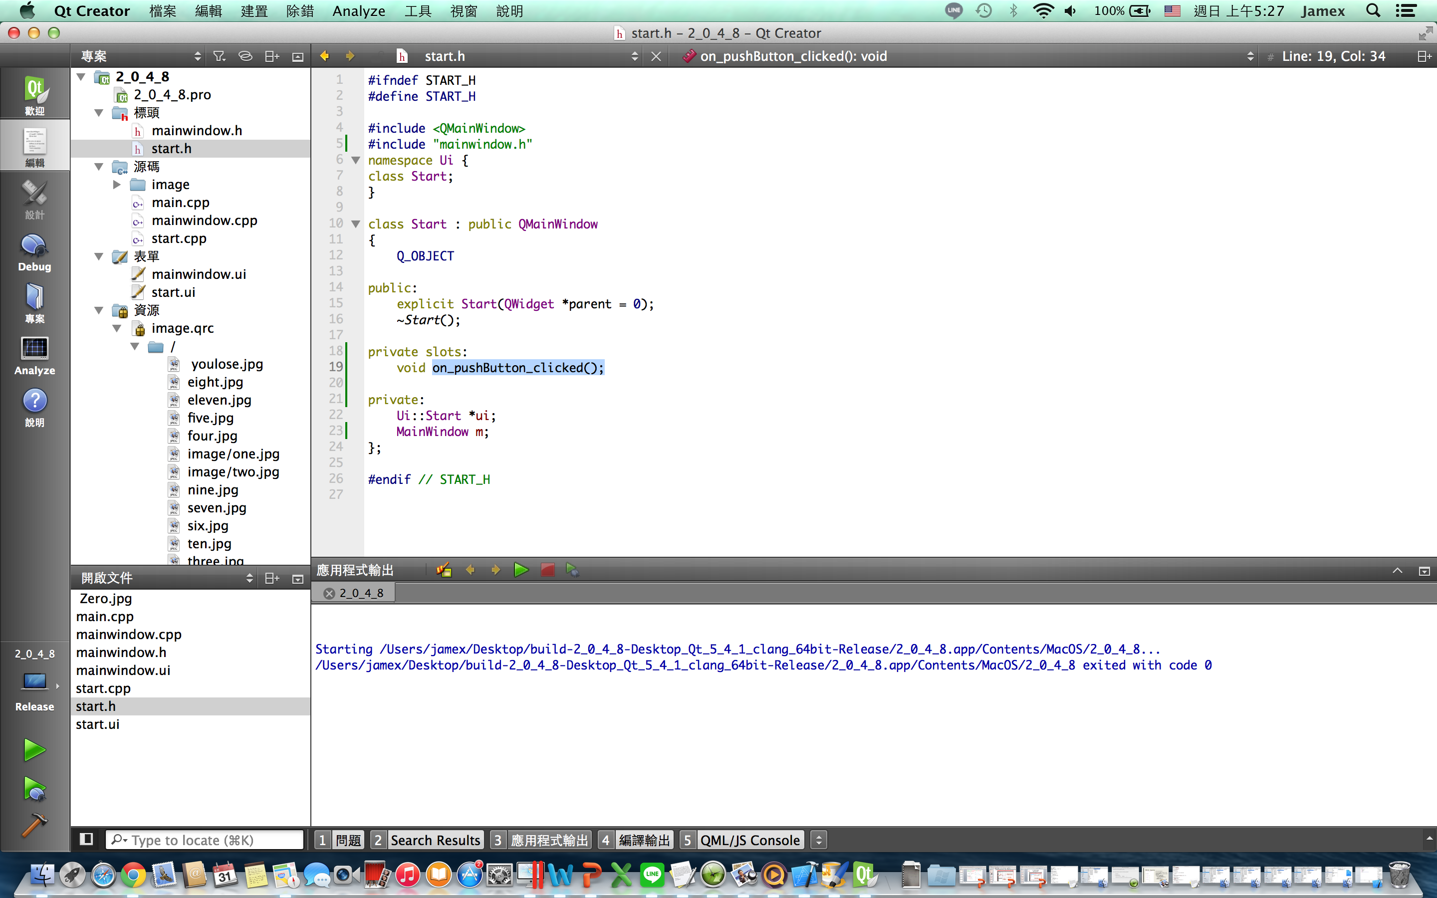

遊戲截圖：

